|  |  |
| --- | --- |
| NewLogoSm | **College of Engineering and Computer Science**  **Mechanical Engineering Department**  ***Mechanical Engineering 390***  ***Fluid Mechanics*** |
| Spring 2008 Number: 11971 Instructor: Larry Caretto |

**Solution to Quiz Six – Momentum Balance**

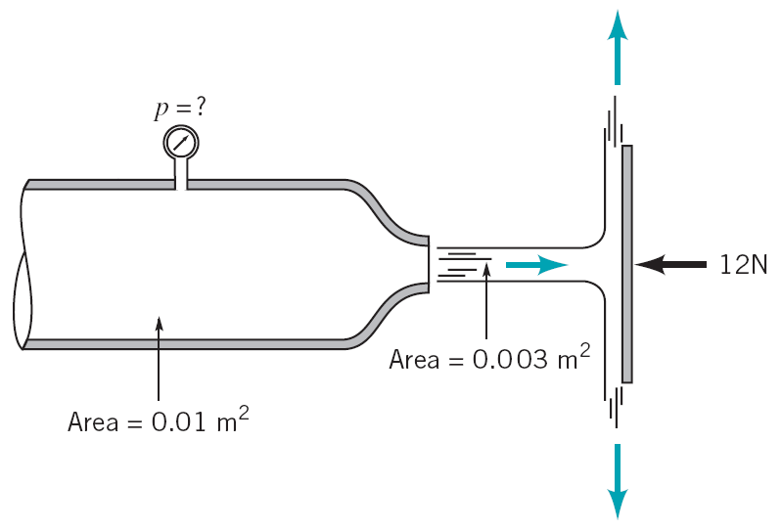**Air flows from a nozzle into the atmosphere and strikes a vertical plate as shown in Figure P5.52, (copied at the right). A horizontal force of 12 N is required to hold the plate in place. Determine the reading on the pressure gage. Assume the flow to be incompressible and frictionless.**

(2)

(1)

(3)

In order to solve this problem we have to find a relationship between the flow at the pressure gage (point 1) and the flow at the outlet (point 2). We then have to augment this relationship with one between the flow leaving the nozzle and the flow striking and leaving the plate. We can combine these two relationships to get an overall equation that relates the restraining force of 12 N to the pressure at point 1.

We can apply the general momentum balance to a control volume between the exit of the nozzle and the flow leaving the plate.



If we assume a steady process, the time derivative is zero and we note that there is no horizontal velocity component at the outlets so the outlet term is zero. The inlet velocity is in the x direction so Vx = V, and we can drop the subscript on density since we are given that the flow is incompressible. With these observations, the momentum equation reduces to the following simple form with one inlet (point 2) and one applied force.



This relates the velocity exiting the nozzle, V2 to the force on the plate. We can relate this velocity and pressure at point 1 by using Bernoulli’s equation. We can use this equation because we are given that the flow is frictionless and incompressible. Here we apply the Bernoulli equation to a streamline in the center of the flow between points 1 and 2.



Points 1 and 2 are at the same elevation for our center streamline, so z1 = z2. The exit pressure p2 is zero since it is atmospheric pressure. Our Bernoulli equation can then be written as follows.



The two velocities are related by the continuity equation: V1A1 = V2A2. Since we have V2 from our force balance, we use the continuity equation to eliminate V1 from the Bernoulli equation.



We can now apply the equation that A2V22 = –Fx from the force balance on the vertical plate to replace V22 in the equation above by –Fx/A2.



**p1 = 1820 N/m2 = 1820 Pa**